# ShopNest Analytics Dashboard Report

## Table of Contents

1. Introduction  
2. Objective of the Dashboard  
3. Key Metrics and Insights  
4. Analytical Questions and Visualizations  
 4.1 Top Categories by Total Price  
 4.2 Delayed Orders Analysis  
 4.3 Monthly Comparison of Delayed and On-Time Orders  
 4.4 Payment Method Analysis  
 4.5 Product Rating Analysis  
 4.6 State-wise Sales Analysis  
 4.7 Seasonal Sales Patterns  
 4.8 Revenue Analysis  
5. Conclusion and Recommendations

## 1. Introduction

The ShopNest Analytics Dashboard was developed as part of a capstone project, with datasets provided by skillOvilla for educational and analytical purposes. These anonymized datasets mimic real-world e-commerce data and include customer transactions, product information, and delivery details. The goal of this project is to showcase data modeling, visualization, and business insight extraction through Power BI.

## 2. Objective of the Dashboard

The primary objective of this dashboard is to analyze customer behavior, product performance, and sales trends while identifying delivery performance and customer satisfaction levels. It aims to assist stakeholders in making informed decisions based on real-time data insights.

Visualization –

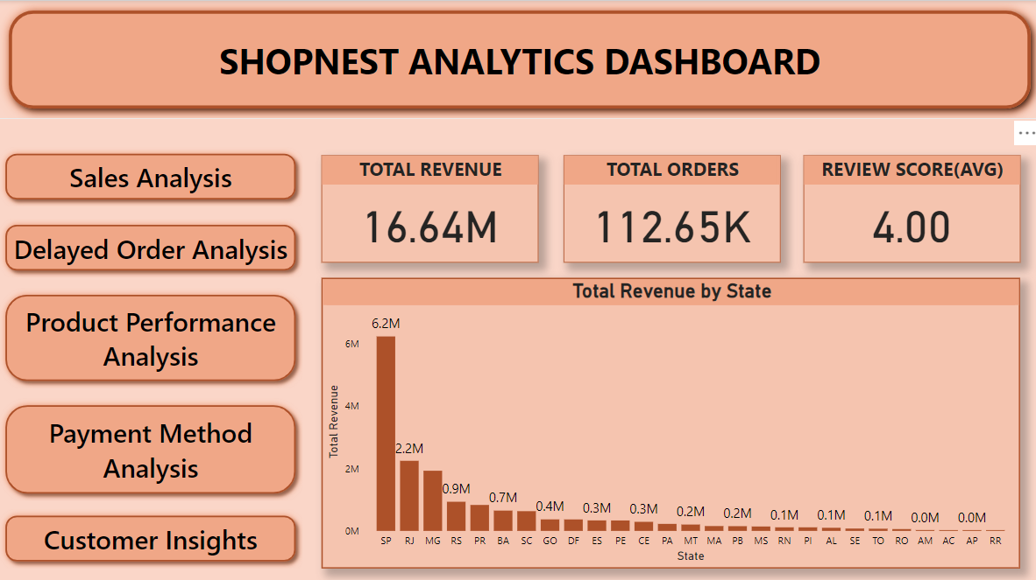

## 3. Key Metrics and Insights

The dashboard highlights the following key metrics:  
- Total Sales  
- Total Orders  
- Average Review Score

- Total Revenue State wise

## 4. Analytical Questions and Visualizations

### 4.1 Top Categories by Total Price

Question Statement: Identify and visually represent the top 10 product categories by total sales.

Visualization –

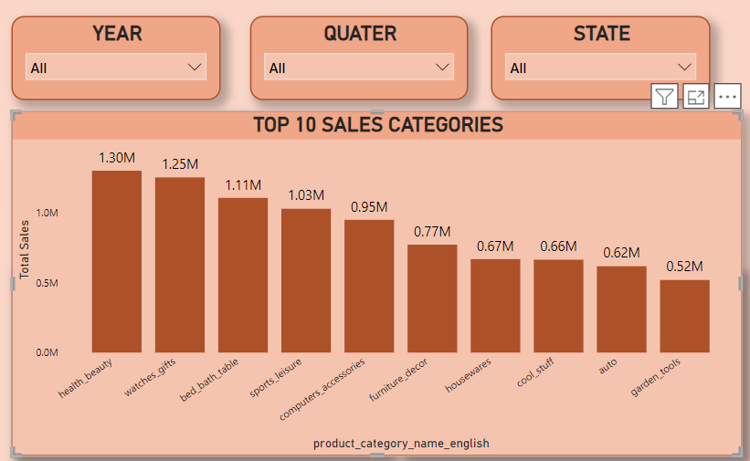

Explanation: This analysis highlights the top-performing product categories by total sales. It helps identify which categories drive revenue and align marketing efforts accordingly.

### 4.2 Delayed Orders Analysis

Question Statement: Determine the number of delayed orders in each category.

Visualization –

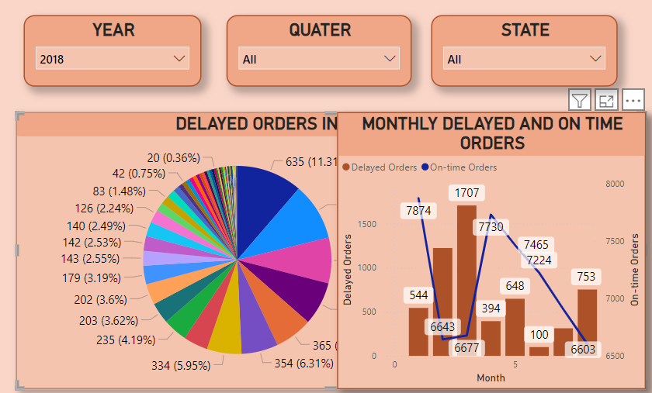

Explanation: This analysis identifies the product categories with the highest number of delayed deliveries, enabling targeted interventions to improve delivery performance.

### 4.3 Monthly Comparison of Delayed and On-Time Orders

Question Statement: Compare the number of delayed orders to on-time orders for each month.

Visualization:

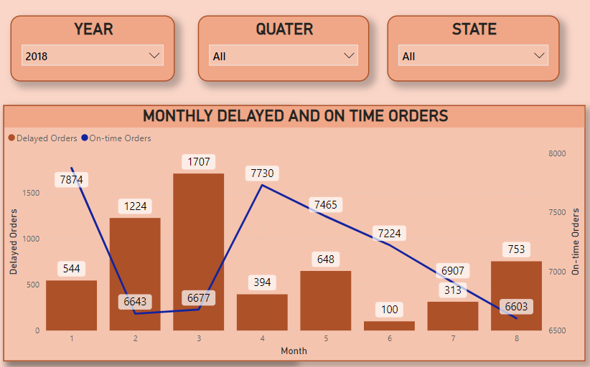

Explanation: This visualization tracks delivery performance over time, highlighting trends in on-time and delayed orders and helping address seasonal challenges.

### 4.4 Payment Method Analysis

Question Statement: Analyze the most frequently used payment methods by customers.

Visualization:

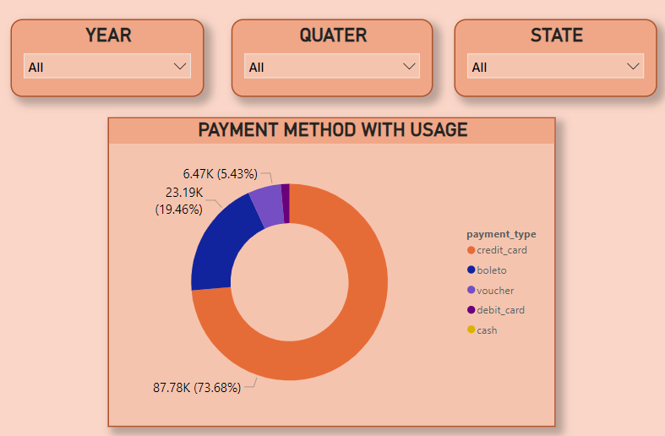

Explanation: Understanding the most popular payment methods allows the business to enhance customer payment experiences and identify preferred modes.

### 4.5 Product Rating Analysis

Question Statement: Determine the top 10 highest-rated products and bottom 10 lowest-rated products.

Visualization:

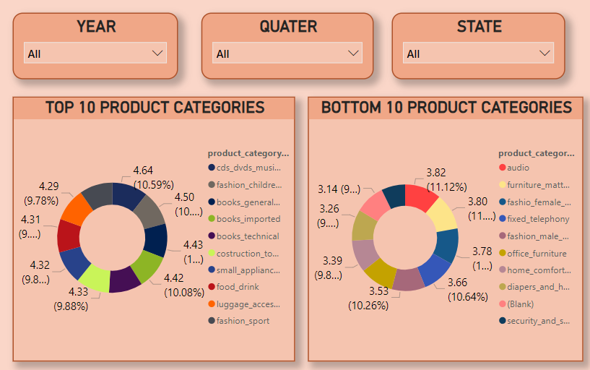

Explanation: This analysis helps identify well-performing products and address issues with poorly rated products to enhance customer satisfaction.

### 4.6 State-wise Sales Analysis

Question Statement: Identify states with high and low sales.

Visualization:

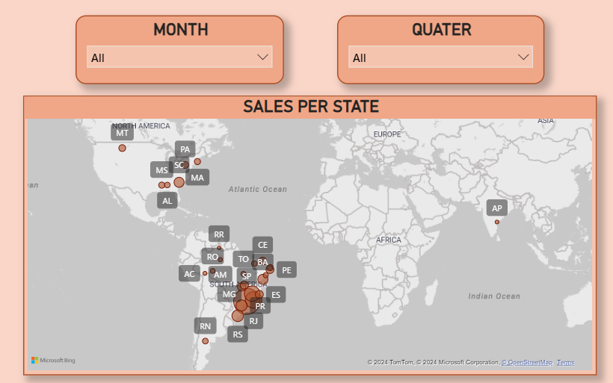

Explanation: This visualization provides a regional overview of sales performance, allowing for targeted marketing and resource allocation.

### 4.7 Seasonal Sales Patterns

Question Statement: Investigate seasonal patterns in sales data.

Visualization:

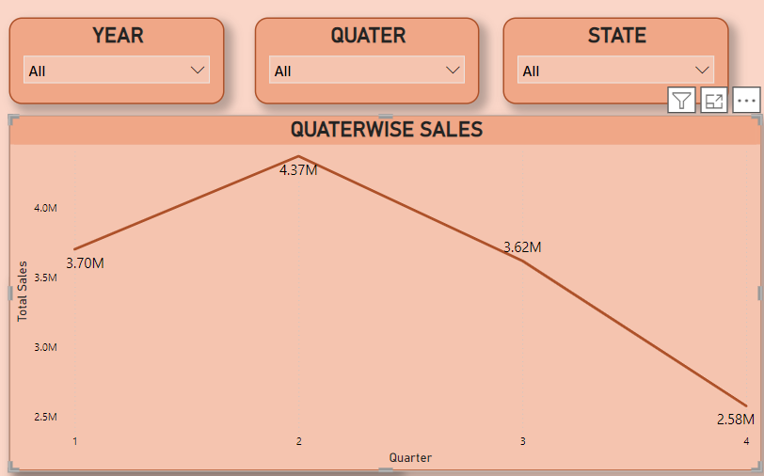

Explanation: This analysis identifies quarterly trends in sales, helping businesses prepare for peak seasons.

### 4.8 Revenue Analysis

Question Statement: Analyze total revenue and its changes over time.

Visualization:

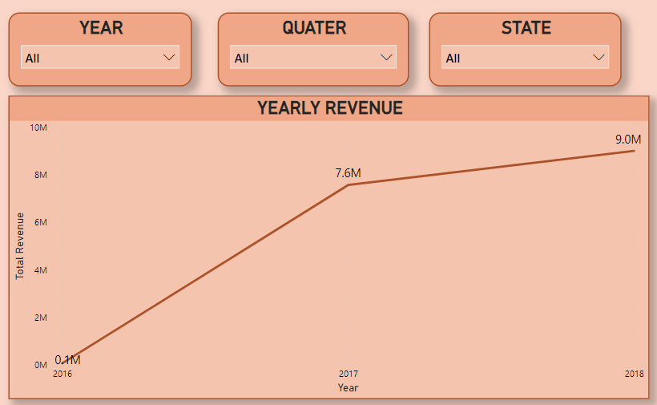

Explanation: This visualization tracks revenue trends over the years, highlighting significant growth or decline patterns.

## 5. Conclusion and Recommendations

The ShopNest Analytics Dashboard provides valuable insights into various aspects of the e-commerce business. Based on the analysis, the following recommendations are made:  
- Focus marketing efforts on top-performing product categories.  
- Improve delivery processes for categories with the highest delays.  
- Optimize payment methods to cater to customer preferences.  
- Address issues with poorly rated products to enhance customer satisfaction.  
- Leverage regional and seasonal trends to maximize sales opportunities.